**上海政法学院申请系统高水平研究生项目操作说明**

**Registration Instructions** **of "High-level Postgraduate Program"**

**第一步：**拷贝网址到浏览器https://admission.shupl.edu.cn/studentLogin，打开上海政法学院国际学生申请系统，点亮“注册Registration”，输入必要的信息。特别注意：Surname and Givenname需要和你护照上的一致，填入后就不能修改了，所以请用实名填写。记住你的密码。点击“注册Register”，你的邮箱会收到激活码，登录你的邮箱获取激活码。

**Step1：**Copy the url to your browser ——https://admission.shupl.edu.cn/studentLogin ，then open the application system for international student of SHUPL. Click “Registration” ，fill in the necessary information. Especially pay attention to“Surname and Given name”.It needs to be the same as that found on your passport，Please remember“It can't be modified after filling it”，so please fill it in with your real name. Meanwhile please remember your password. Click“Register”，your email will get the activation code. Please login your mailbox for the activation code。

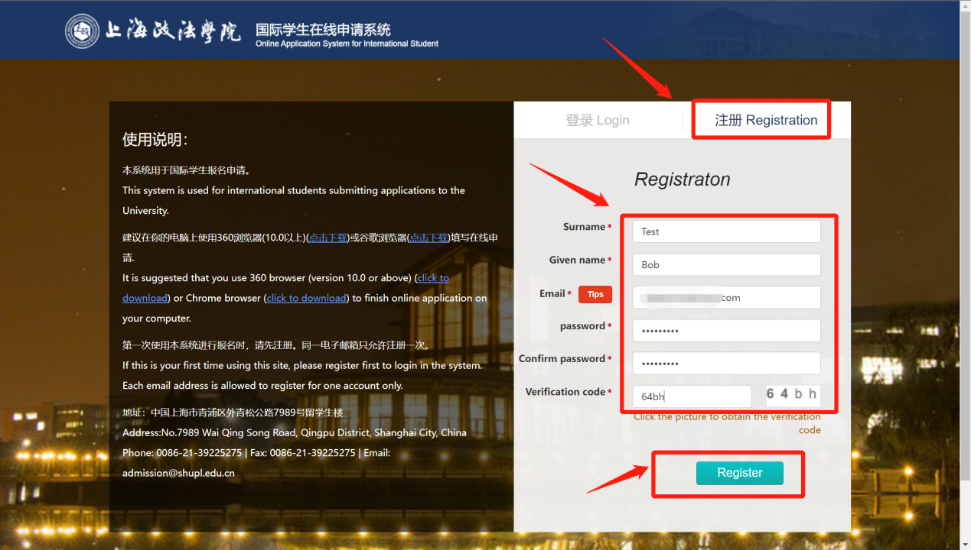

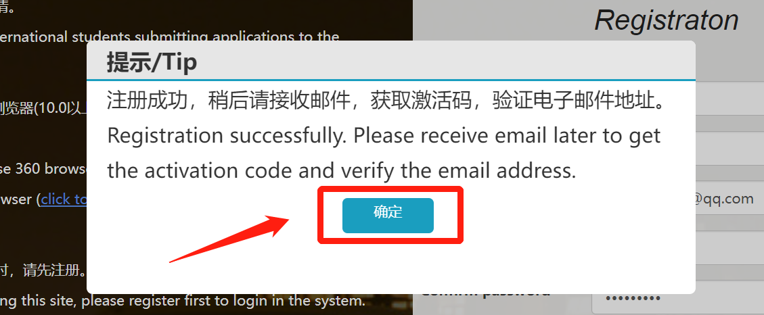

**第二步，**激活账户。先点亮“登录”,点击“active account”,输入你的邮箱和收到的数字激活码，然后收到激活成功的提示。

**Step2:** Activate your account. Click“Login”，and continue to click“active account”, fill in your email and the digital activation code you received, and then you will receive a prompt for a successful activation.

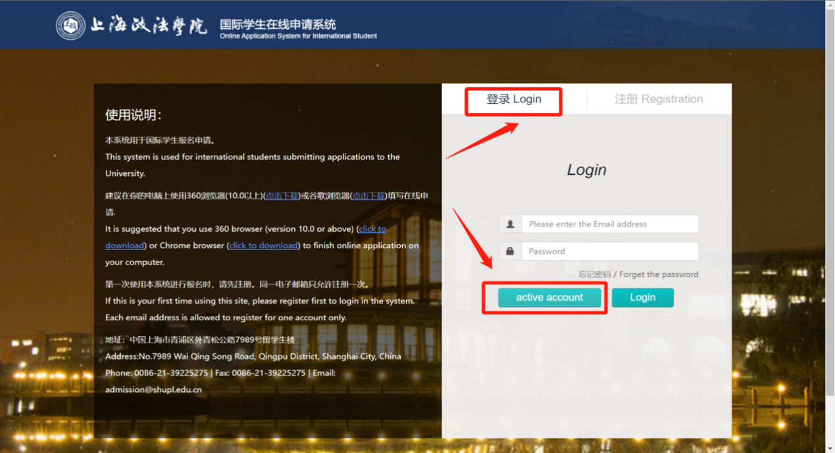

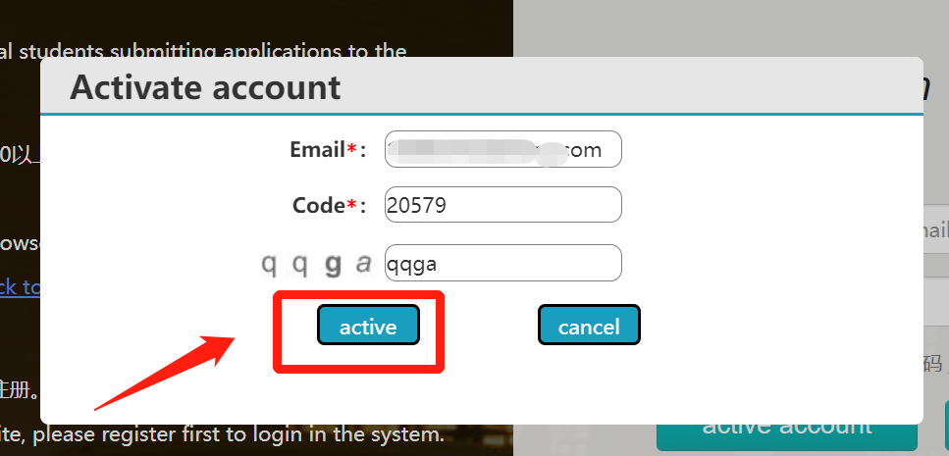

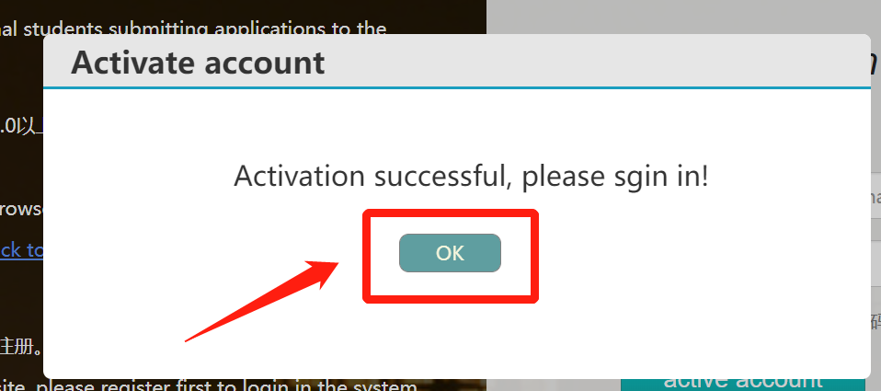

**第三步，**登录账户，点击“发起申请/start Application”，系统会跳出来阅读提示信息。点击“已阅读并开始办理”按钮。

**Step3:** Login account, please click“start Application”，a reading prompt message will appear on the system. And click“Read complete and start processing”.

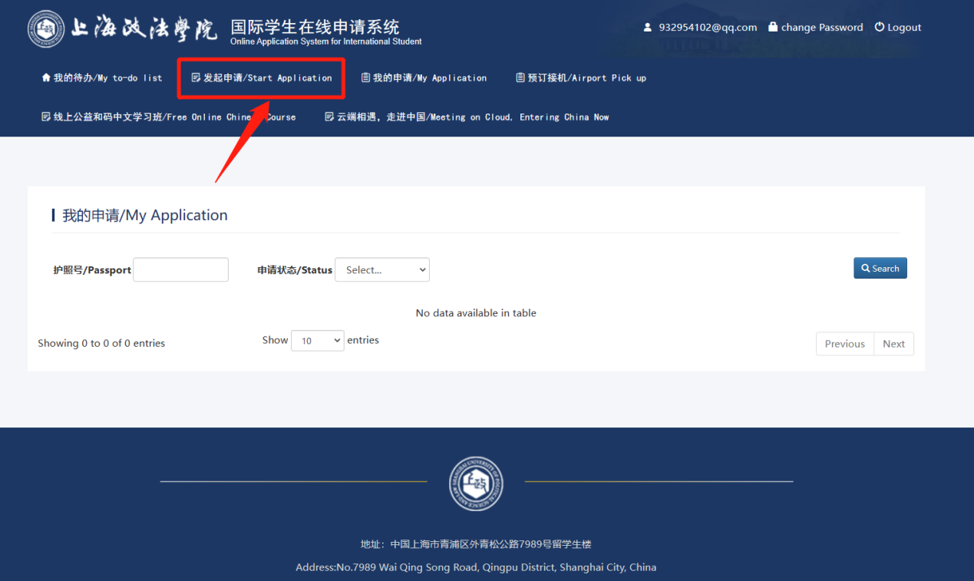

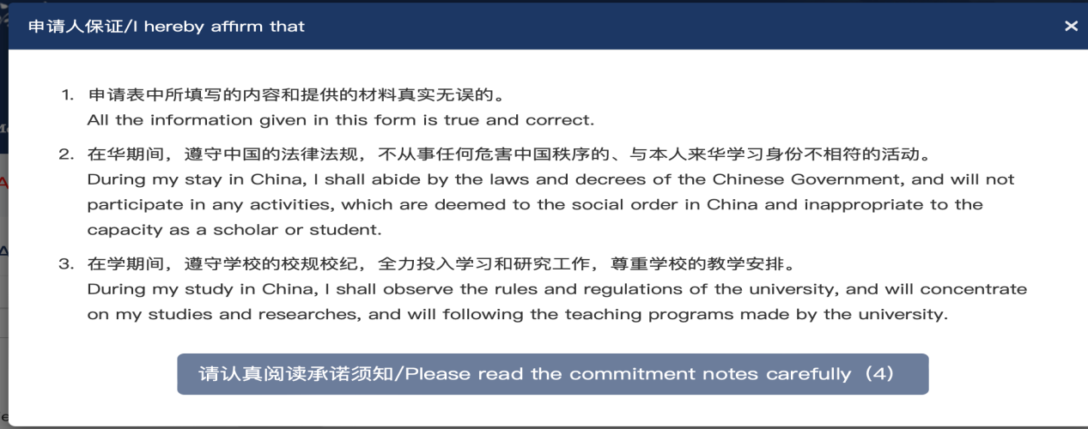

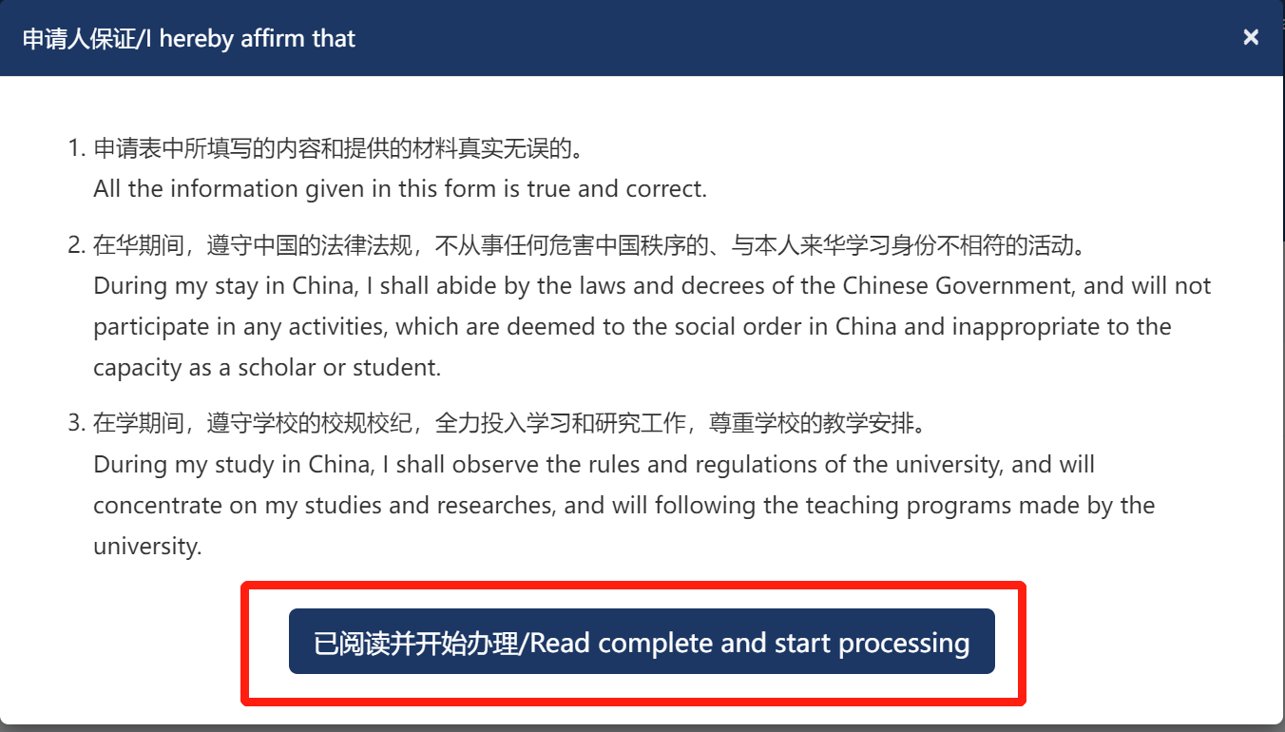

**第四步，**选择“2024年国际学生招生项目”。

**Step4:** Select“2024 International Student for Autumn Admission”

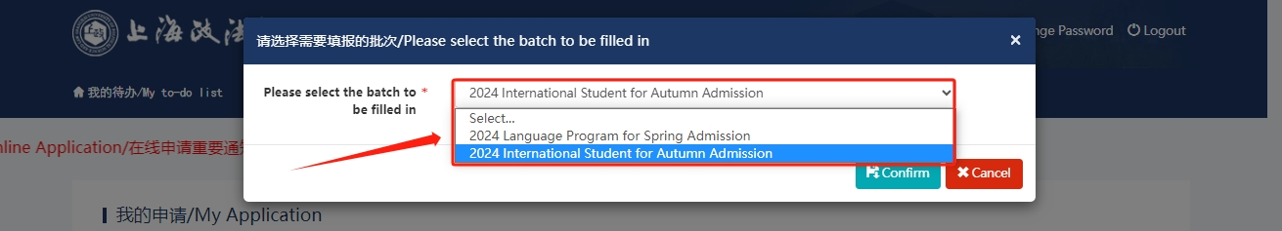

**第五步，**根据系统提示分步填写你的相关信息，在第5步中，提交申请。填写过程中你可以随时保存填写的信息，最后点提交。

**Step5:** Follow the system prompts to fill in your relevant information step by step, in step 5, submit the application. You can save the information at any time during the filling process, and click Submit at the end.

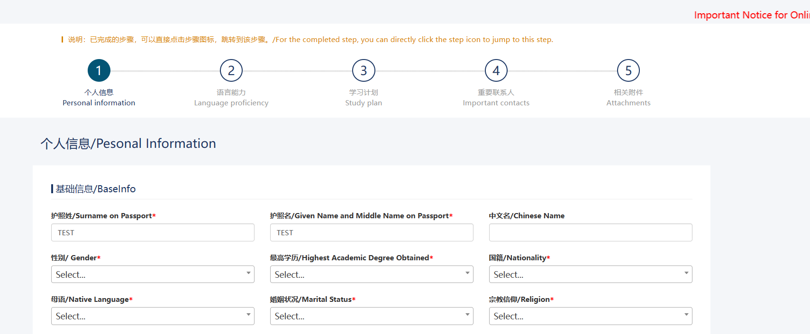

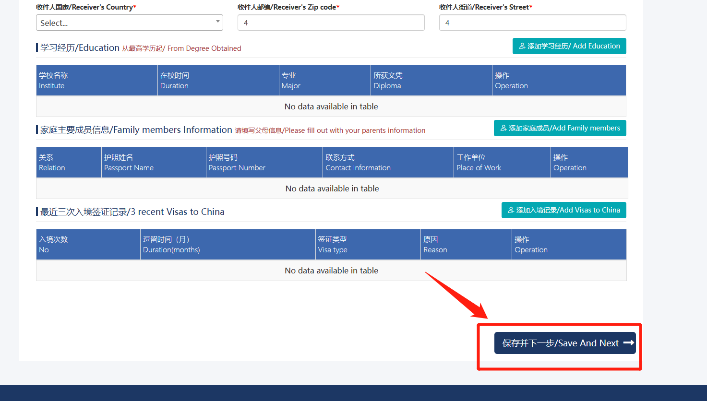

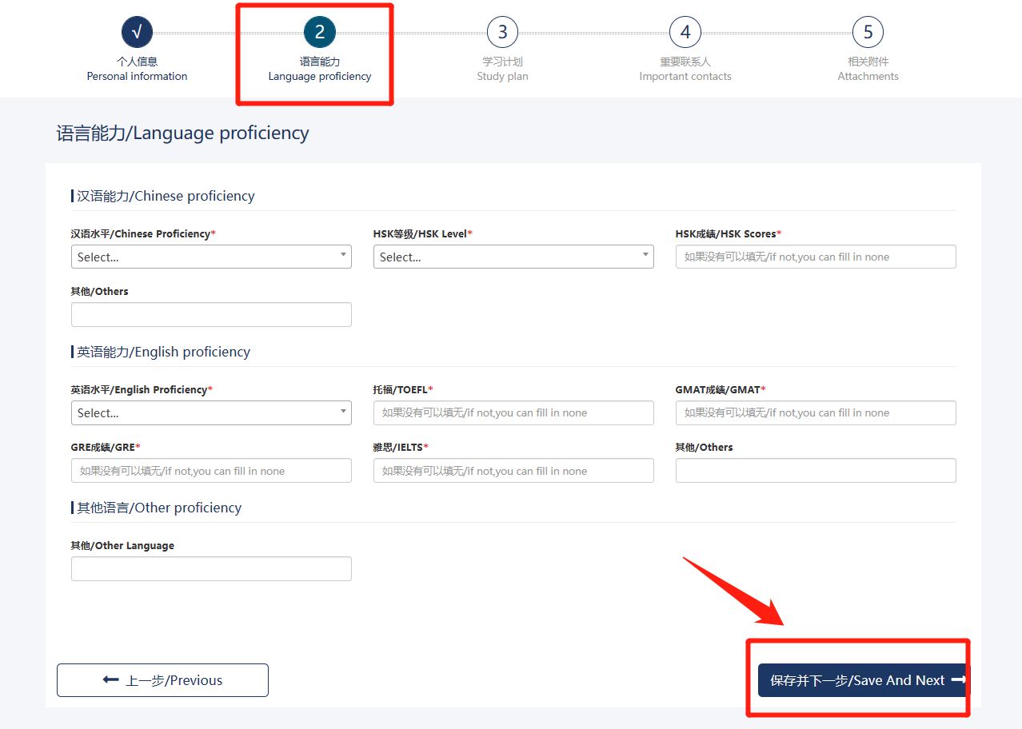

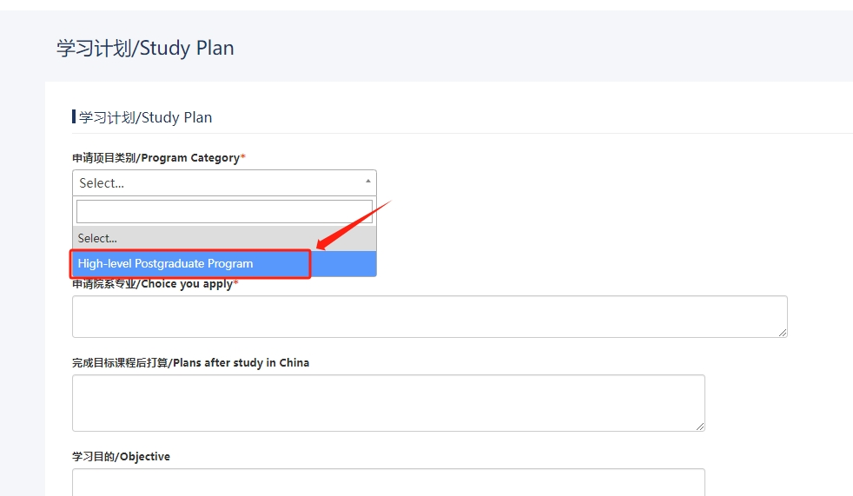

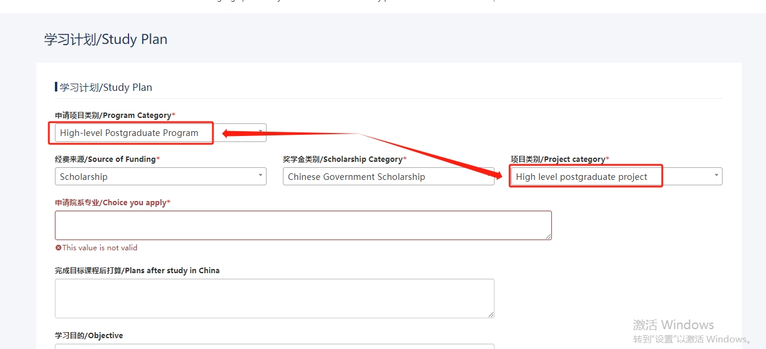

（若有奖学金，项目类别与申请项目类别保持一致，皆选择高水平研究生项目）

（If you have a scholarship, the“ Program Category” is the same as the “Project Category” of the application, choose “High-level Postgraduate Program”）

